**SBA 3:**

To complete the activity as explained across from each of the group.

Details are as below:





GROUP-2 : CYPRESS

* HTML CODE

|  |  |  |  |  |  |  |  |  |  |  |  |  |  |  |  |  |  |  |  |  |  |  |  |  |  |  |  |  |  |  |  |  |  |  |  |  |  |  |  |  |  |  |  |  |  |  |  |  |  |  |  |  |  |  |  |  |  |  |  |  |  |  |  |  |  |  |  |  |  |  |  |  |  |  |  |  |  |  |  |  |  |  |  |  |  |  |  |  |  |  |  |  |  |  |  |  |  |  |  |  |  |  |  |  |  |  |  |  |  |  |  |  |  |  |  |  |  |  |  |  |  |  |  |  |  |  |  |  |  |  |  |  |  |  |  |  |  |  |  |  |  |  |  |  |  |  |  |  |  |  |  |  |  |  |  |  |  |  |  |  |  |  |  |  |  |  |  |  |  |  |  |  |  |  |  |  |  |  |  |  |  |  |  |  |  |  |  |  |  |  |  |  |  |  |  |  |  |  |  |  |  |  |  |  |  |  |  |  |  |  |  |  |  |  |  |  |  |  |  |  |  |  |  |  |  |  |  |  |  |  |  |  |  |  |  |  |  |  |  |  |  |  |  |  |  |  |  |  |  |  |  |  |  |  |  |  |  |  |  |  |  |  |  |  |  |  |  |  |  |  |  |  |  |  |  |  |  |  |  |  |  |  |  |  |  |  |  |  |  |  |  |  |  |  |  |  |  |  |  |  |  |  |  |  |  |  |  |  |  |  |  |  |  |  |  |  |  |  |  |  |  |  |  |  |  |  |  |  |  |  |  |  |  |  |  |  |  |  |  |  |  |  |  |  |  |  |  |  |  |  |  |  |  |  |  |  |  |  |  |  |  |  |  |  |  |  |  |  |  |  |  |  |  |
| --- | --- | --- | --- | --- | --- | --- | --- | --- | --- | --- | --- | --- | --- | --- | --- | --- | --- | --- | --- | --- | --- | --- | --- | --- | --- | --- | --- | --- | --- | --- | --- | --- | --- | --- | --- | --- | --- | --- | --- | --- | --- | --- | --- | --- | --- | --- | --- | --- | --- | --- | --- | --- | --- | --- | --- | --- | --- | --- | --- | --- | --- | --- | --- | --- | --- | --- | --- | --- | --- | --- | --- | --- | --- | --- | --- | --- | --- | --- | --- | --- | --- | --- | --- | --- | --- | --- | --- | --- | --- | --- | --- | --- | --- | --- | --- | --- | --- | --- | --- | --- | --- | --- | --- | --- | --- | --- | --- | --- | --- | --- | --- | --- | --- | --- | --- | --- | --- | --- | --- | --- | --- | --- | --- | --- | --- | --- | --- | --- | --- | --- | --- | --- | --- | --- | --- | --- | --- | --- | --- | --- | --- | --- | --- | --- | --- | --- | --- | --- | --- | --- | --- | --- | --- | --- | --- | --- | --- | --- | --- | --- | --- | --- | --- | --- | --- | --- | --- | --- | --- | --- | --- | --- | --- | --- | --- | --- | --- | --- | --- | --- | --- | --- | --- | --- | --- | --- | --- | --- | --- | --- | --- | --- | --- | --- | --- | --- | --- | --- | --- | --- | --- | --- | --- | --- | --- | --- | --- | --- | --- | --- | --- | --- | --- | --- | --- | --- | --- | --- | --- | --- | --- | --- | --- | --- | --- | --- | --- | --- | --- | --- | --- | --- | --- | --- | --- | --- | --- | --- | --- | --- | --- | --- | --- | --- | --- | --- | --- | --- | --- | --- | --- | --- | --- | --- | --- | --- | --- | --- | --- | --- | --- | --- | --- | --- | --- | --- | --- | --- | --- | --- | --- | --- | --- | --- | --- | --- | --- | --- | --- | --- | --- | --- | --- | --- | --- | --- | --- | --- | --- | --- | --- | --- | --- | --- | --- | --- | --- | --- | --- | --- | --- | --- | --- | --- | --- | --- | --- | --- | --- | --- | --- | --- | --- | --- | --- | --- | --- | --- | --- | --- | --- | --- | --- | --- | --- | --- | --- | --- | --- | --- | --- | --- | --- | --- | --- | --- | --- | --- | --- | --- | --- | --- | --- | --- | --- | --- | --- | --- | --- | --- | --- | --- | --- | --- | --- | --- | --- | --- | --- | --- | --- | --- | --- | --- | --- | --- | --- | --- | --- | --- | --- | --- | --- |
|  | |  | | --- | | <html> | |  |  | |  | <head> | |  | <title>Angular JS Forms</title> | |  | <script src="https://ajax.googleapis.com/ajax/libs/angularjs/1.3.14/angular.min.js"></script> | |  | <meta name="viewport" content="width=device-width, initial-scale=1"> | |  | <link href="https://cdn.jsdelivr.net/npm/bootstrap@5.1.1/dist/css/bootstrap.min.css" rel="stylesheet"> | |  | <script src="https://cdn.jsdelivr.net/npm/bootstrap@5.1.1/dist/js/bootstrap.bundle.min.js"></script> | |  | <link rel="stylesheet" href="https://maxcdn.bootstrapcdn.com/bootstrap/3.4.1/css/bootstrap.min.css"> | |  | <script src="https://ajax.googleapis.com/ajax/libs/jquery/3.5.1/jquery.min.js"></script> | |  | <script src="https://maxcdn.bootstrapcdn.com/bootstrap/3.4.1/js/bootstrap.min.js"></script> | |  |  | |  |  | |  | <style> | |  | table, | |  | th, | |  | td { | |  | border: 1px solid grey; | |  | border-collapse: collapse; | |  | padding: 5px; | |  | } | |  |  | |  | table tr:nth-child(odd) { | |  | background-color: #f2f2f2; | |  | } | |  |  | |  | table tr:nth-child(even) { | |  | background-color: #ffffff; | |  | } | |  | </style> | |  |  | |  | </head> | |  | <body> | |  |  | |  | <div class="jumbotron"> | |  | <h2>Welcome to this page, Please fill your details and preferences</h2> | |  | </div> | |  | <h4>Choose the appropriate dropdown option</h4> | |  | <div class="container"> | |  | <div class="dropdown"> | |  | <button class="btn btn-default dropdown-toggle" type="button" data-toggle="dropdown">Form A | |  | <span class="caret"></span></button> | |  | <ul class="dropdown-menu"> | |  | <li><a href="#">Form A</a></li> | |  | <li><a href="#">Form B</a></li> | |  | <li><a href="#">Form C</a></li> | |  | </ul> | |  | </div> | |  | </div> | |  |  | |  | <div ng-app="mainApp" ng-controller="studentController"> | |  |  | |  |  | |  | <form name="studentForm" novalidate> | |  | <table border="0"> | |  | <tr> | |  | <td>Enter first name:</td> | |  | <td><input name="firstname" type="text" ng-model="firstName" required> | |  | <span style="color:red" ng-show="studentForm.firstname.$dirty && studentForm.firstname.$invalid"> | |  | <span ng-show="studentForm.firstname.$error.required">First Name is required.</span> | |  | </span> | |  | </td> | |  | </tr> | |  |  | |  | <tr> | |  | <td>Enter last name: </td> | |  | <td><input name="lastname" type="text" ng-model="lastName" required> | |  | <span style="color:red" ng-show="studentForm.lastname.$dirty && studentForm.lastname.$invalid"> | |  | <span ng-show="studentForm.lastname.$error.required">Last Name is required.</span> | |  | </span> | |  | </td> | |  | </tr> | |  |  | |  | <tr> | |  | <td>Email: </td> | |  | <td><input name="email" type="email" ng-model="email" length="100" required> | |  | <span style="color:red" ng-show="studentForm.email.$dirty && studentForm.email.$invalid"> | |  | <span ng-show="studentForm.email.$error.required">Email is required.</span> | |  | <span ng-show="studentForm.email.$error.email">Invalid email address.</span> | |  | </span> | |  | </td> | |  | </tr> | |  |  | |  | <tr> | |  | <td>Phone: </td> | |  | <td><input name="Phone" type="text" ng-model="Phone" length="100" required> | |  | <span style="color:red" ng-show="studentForm.email.$dirty && studentForm.email.$invalid"> | |  | <span ng-show="studentForm.email.$error.required">Phone is mandatory.</span> | |  | <span ng-show="studentForm.email.$error.email">Invalid phone number</span> | |  | </span> | |  | </td> | |  | </tr> | |  |  | |  | <tr> | |  | <tr> | |  | <td>Marital status:</td> | |  | <td> | |  | <select id="mstatus" name="mstatus"> | |  | <option value="Prefer not to say" selected>Prefer not to say</option> | |  | <option value="Unmarried">Unmarried</option> | |  | <option value="Prefer not to say">Married</option> | |  |  | |  | </select> | |  | </td> | |  | </tr> | |  |  | |  | </tr> | |  | <tr> | |  | <td>Select the location:</td> | |  | <td> | |  | <select id="location" name="location"> | |  | <option value="Trivadrum" selected>Trivandrum</option> | |  | <option value="Cochin">Cochin</option> | |  | <option value="Bangalore">Bangalore</option> | |  | <option value="Mysore">Mysore</option> | |  | <option value="Chennai">Chennai</option> | |  | </select> | |  | </td> | |  | </tr> | |  | <tr> | |  |  | |  | <td> | |  | <h4>Languages Known:</h4> | |  | </td> | |  | <td> | |  | <input type="checkbox" id="Language 1" name="English" value="English"> | |  | <label for="English"> English</label><br> | |  | <input type="checkbox" id="Language 2" name="Hindi" value="Hindi"> | |  | <label for="Hindi"> Hindi</label><br> | |  | <input type="checkbox" id="Language 3" name="Spanish" value="Spanish"> | |  | <label for="Spanish"> Spanish</label><br> | |  | <input type="checkbox" id="Language 4" name="Malayalam" value="Malayalam"> | |  | <label for="Malayalam"> Malayalam</label><br> | |  | <input type="checkbox" id="Language 5" name="Tamil" value="Tamil"> | |  | <label for="Tamil"> Tamil</label><br><br> | |  | </tr> | |  | </td> | |  | <tr> | |  | <td> | |  | <h4>Select your preferences</h4> | |  | </td> | |  | <td> | |  | <h4>Choose either one of the option</h4> | |  | <label id="1"><input type="radio" id = "Eat" name = "myact" value = "Eat" >Eat</label><span> or </span><label id="2"><input type="radio" id = "Sleep" name = "myact" value = "Sleep" >Sleep</label><br> | |  | <label id="3"><input type="radio" id = "Tall" name = "myact1" value = "Tall" >Tall</label><span> or </span><label id="4"><input type="radio" id = "Short" name = "myact1" value = "Short" >Short</label><br> | |  | <label id="5"><input type="radio" id = "Run" name = "myact2" value = "Run" >Run</label><span>or </span><label id="6"><input type="radio" id = "Walk" name = "myact2" value = "Walk" >Walk</label><br> | |  | <label id="7"><input type="radio" id = "Talk" name = "myact3" value = "Talk" >Talk</label><span> or </span><label id="8"><input type="radio" id = "Play" name = "myact3" value = "Play" >Play</label><br> | |  | <label id="9"><input type="radio" id = "Dance" name = "myact4" value = "Dance" >Dance</label><span> or </span><label id="10"><input type="radio" id = "Jump" name = "myact4" value = "Jump" >Jump</label><br> | |  |  | |  | </tr> | |  | </td> | |  |  | |  | <tr> | |  | <td> | |  | <button ng-click=<a href="#" class="btn btn-info" role="button">For Reset</a></button> | |  | </td> | |  | <td> | |  | <button ng-disabled="studentForm.firstname.$dirty && | |  | studentForm.firstname.$invalid || studentForm.lastname.$dirty && | |  | studentForm.lastname.$invalid || studentForm.email.$dirty && | |  | studentForm.email.$invalid" ng-click=<a href="#" class="btn btn-info" role="button">Submit | |  | Button</a></button> | |  |  | |  | </td> | |  | </tr> | |  | </table> | |  | </form> | |  | </div> | |  | <script> | |  | var mainApp = angular.module("mainApp", []); | |  |  | |  | mainApp.controller('studentController', function ($scope) { | |  | $scope.reset = function () { | |  | $scope.firstName = "Anagha"; | |  | $scope.lastName = ""; | |  | $scope.email = ""; | |  | $scope.mstatus = "Married/Unmarried"; | |  | $scope.Phone = ""; | |  | } | |  | $scope.reset(); | |  | }); | |  | </script> | |  | </body> | |  |  | |  | </html> |   OUTPUT:     * TESTING SCENARIOS IN CYPRESS * CODE | | |  |
| describe('simple Test', function () { |
|  | //Test case |
|  | it('Scenario 1', function (){ |
|  | // test step for URL launching |
|  | cy.visit("http://127.0.0.1:5500/cypress/project-specfile.html"); |
|  |  |
|  | }); |
|  |  |
|  | it('Scenario 2', function (){ |
|  |  |
|  | cy.get('[type="radio"]').first().check() |
|  | }); |
|  | it('Scenario 3', function (){ |
|  |  |
|  | cy.get('[type="checkbox"]').first().check() |
|  | }); |
|  |  |
|  | it('Scenario 4', function (){ |
|  |  |
|  | cy.title().should('eq', 'Angular JS Forms') |
|  | }); |
|  |  |
|  | it('Scenario 5', function (){ |
|  |  |
|  | cy.get('[name="firstname"]').type(' Mohan') |
|  | cy.get('[name="lastname"]').type('A') |
|  | cy.get('[name="email"]').type('anagha@gmail.com') |
|  | cy.get('[name="Phone"]').type('1234567890') |
|  |  |
|  | }); |
|  |  |
|  | it('Scenario 6', function (){ |
|  |  |
|  | cy.get('[value="Jump"]').check() |
|  | }); |
|  |  |
|  | it('Scenario 7', function (){ |
|  |  |
|  | cy.get('[value="Spanish"]').check() |
|  | }); |
|  | it('Scenario 8', function (){ |
|  |  |
|  | cy.get('#location').select('Cochin') |
|  | }); |
|  |  |
|  | it('Scenario 9', function (){ |
|  |  |
|  | cy.get('#location').select('Trivandrum') |
|  | }); |
|  |  |
|  |  |
|  | it('Scenario 10', function (){ |
|  |  |
|  | cy.visit("http://127.0.0.1:5500/cypress/project-specfile.html") |
|  | cy.get('#mstatus').select('Unmarried') |
|  |  |
|  | }); |
|  | }); |
|  |  |

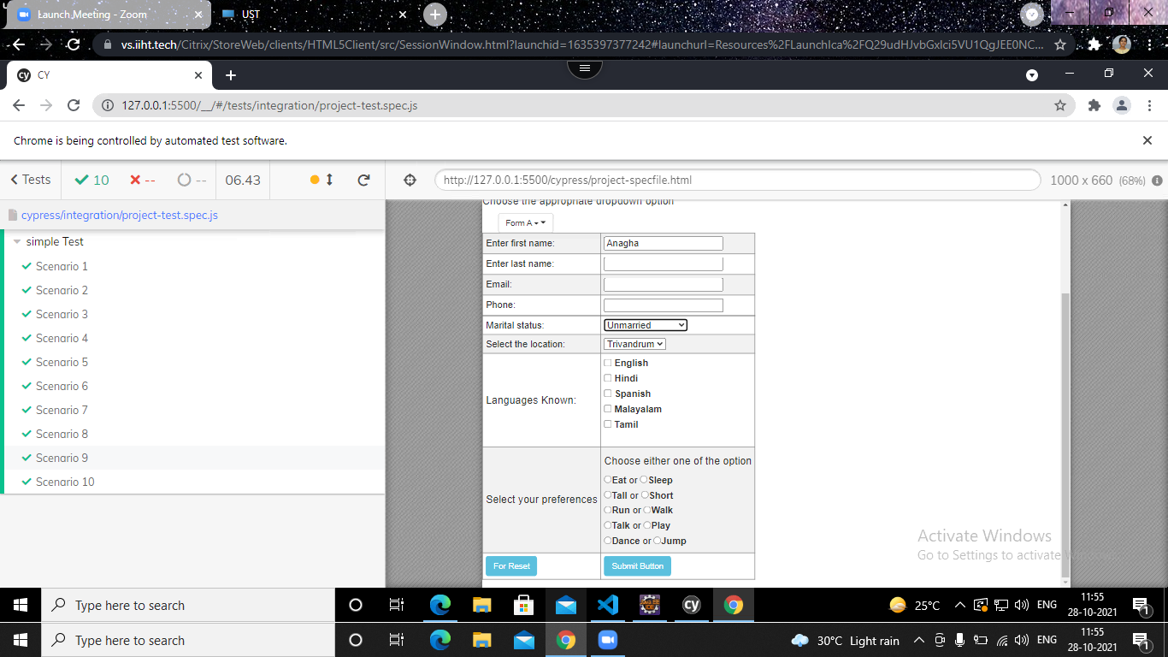

* TESTCASE 1

 it('Scenario 1', function (){

          // test step for URL launching

          cy.visit("http://192.168.133.1:8080/cypress/project-specfile.html");

       });

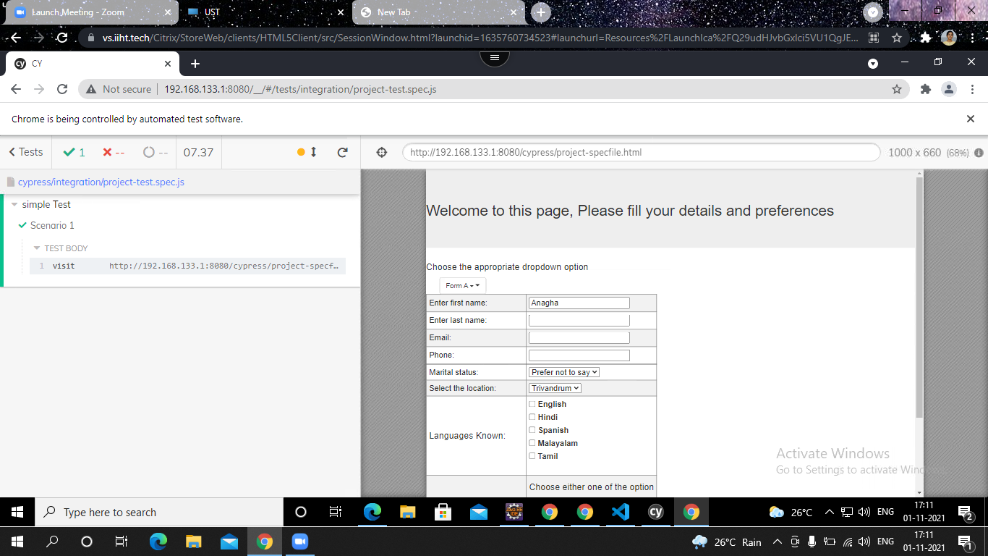

* TESTCASE 2

it('Scenario 2', function (){

         cy.get('[type="radio"]').first().check()

      });

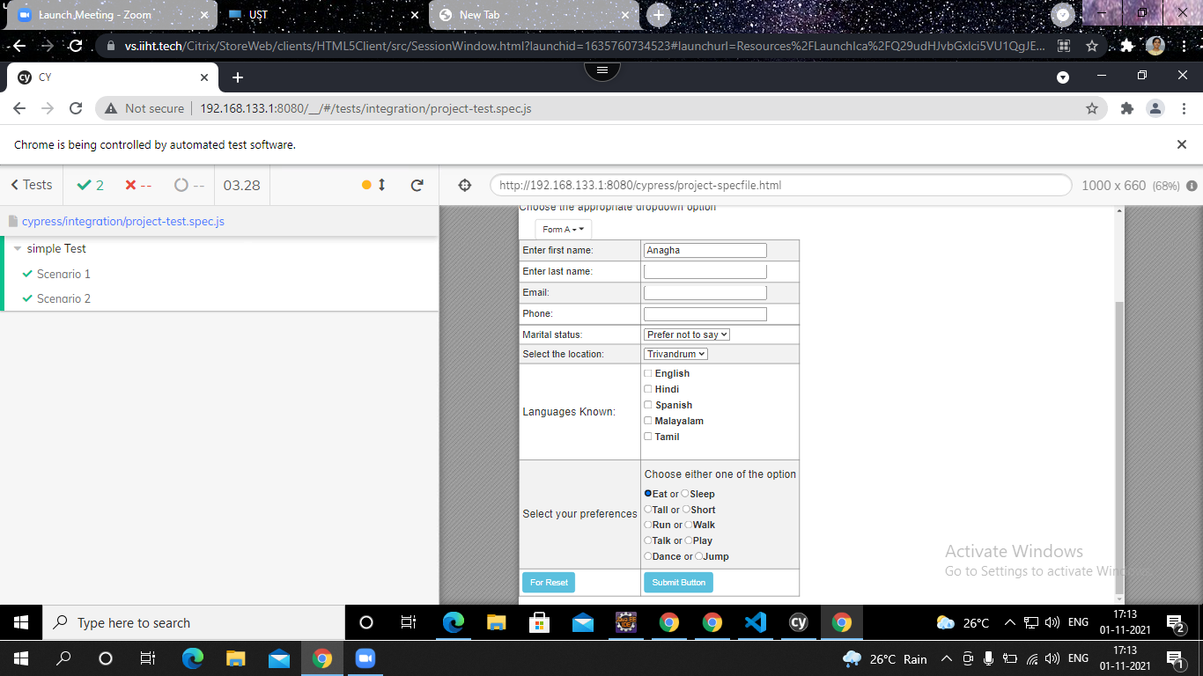

TESTCASE 3

it('Scenario 3', function (){

         cy.get('[type="checkbox"]').first().check()

      });

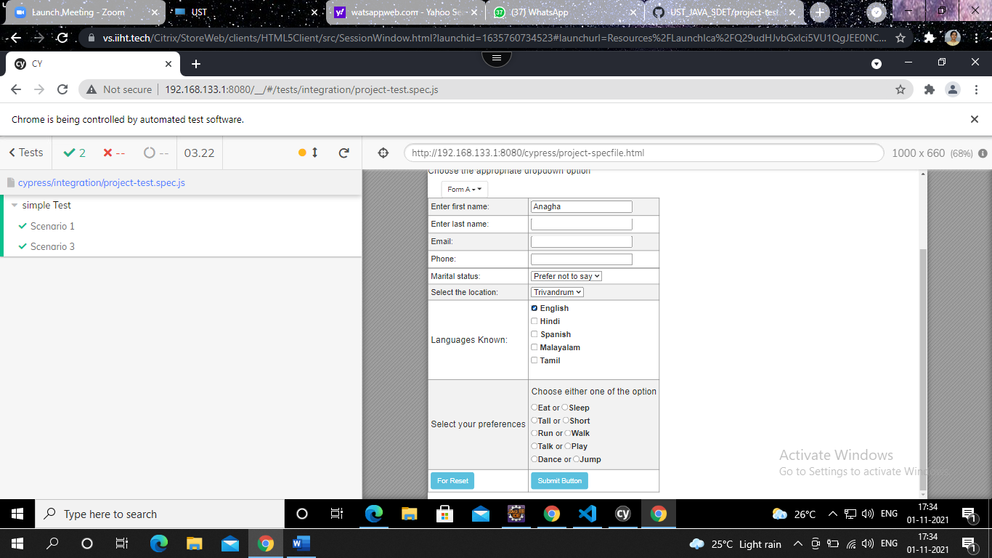

* TESTCASE 4

it('Scenario 4', function (){

         cy.title().should('eq', 'Angular JS Forms')

      });

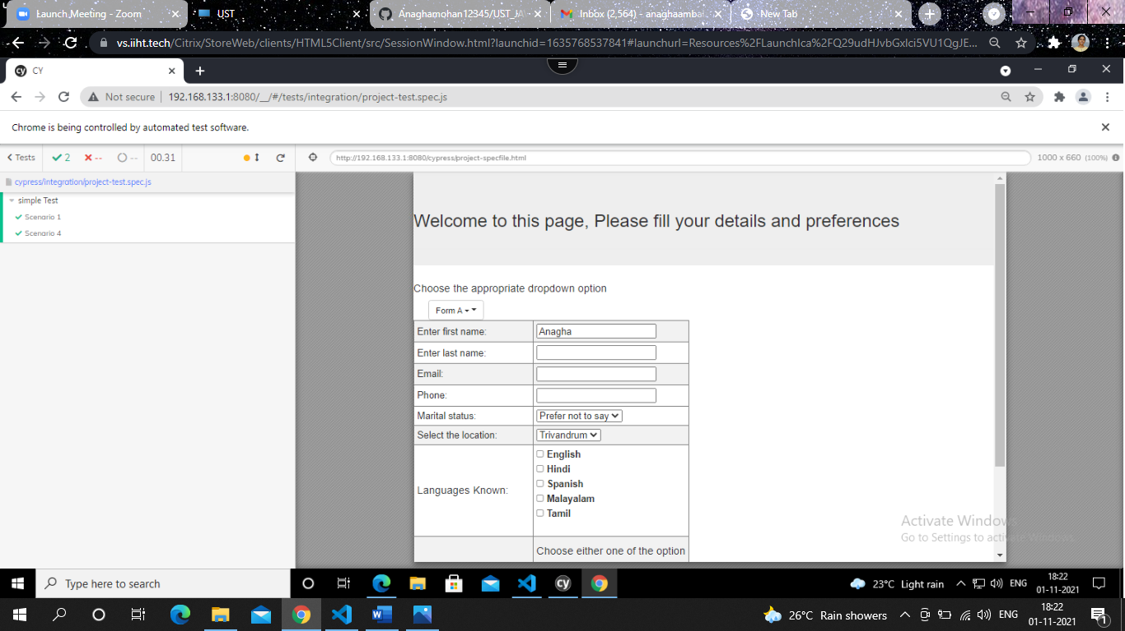

* TESTCASE 5

it('Scenario 5', function (){

         cy.get('[name="firstname"]').type(' Mohan')

         cy.get('[name="lastname"]').type('A')

         cy.get('[name="email"]').type('anagha@gmail.com')

         cy.get('[name="Phone"]').type('1234567890')

      });

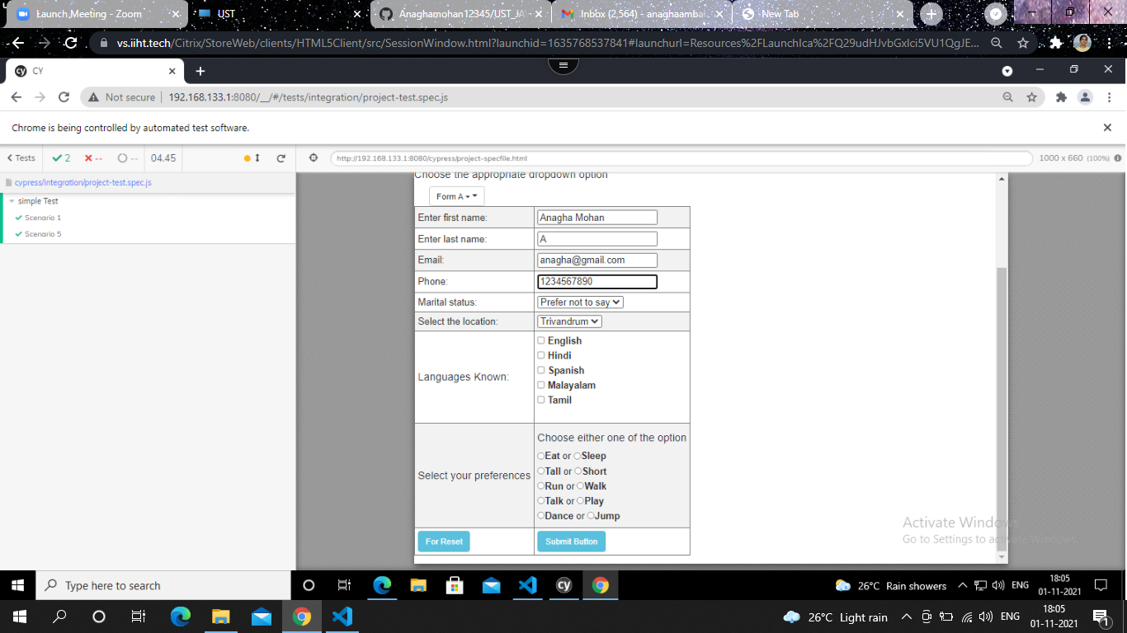

* TESTCASE 6

 it('Scenario 6', function (){

         cy.get('[value="Jump"]').check()

      });

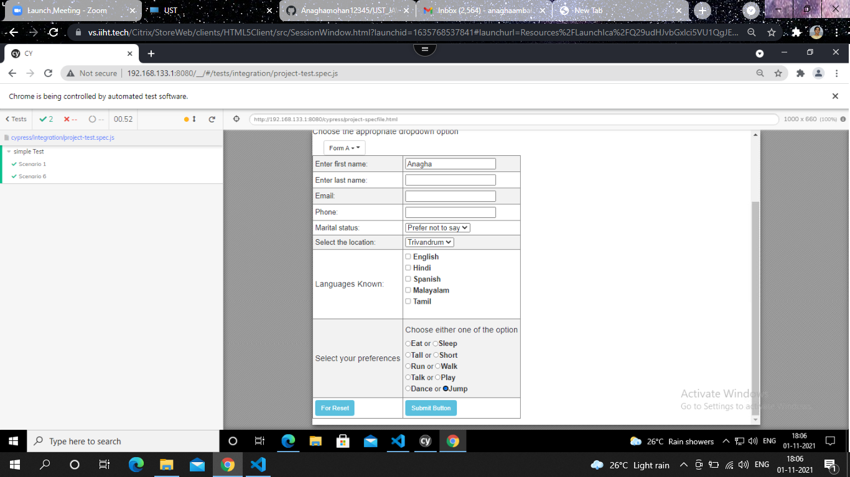

* TESTCASE 7

it('Scenario 7', function (){

         cy.get('[value="Spanish"]').check()

      });

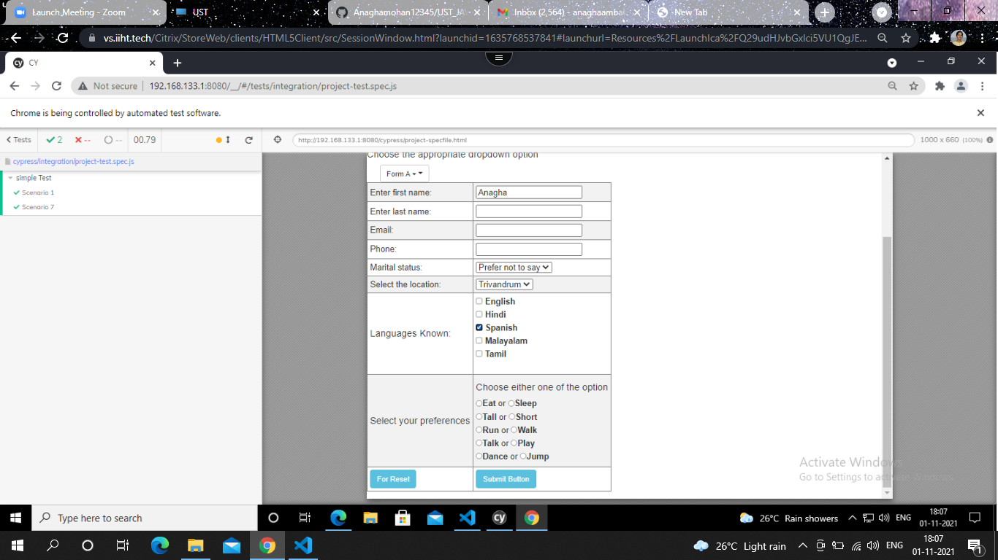

* TESTCASE 8

 it('Scenario 8', function (){

         cy.get('#location').select('Cochin')

      });

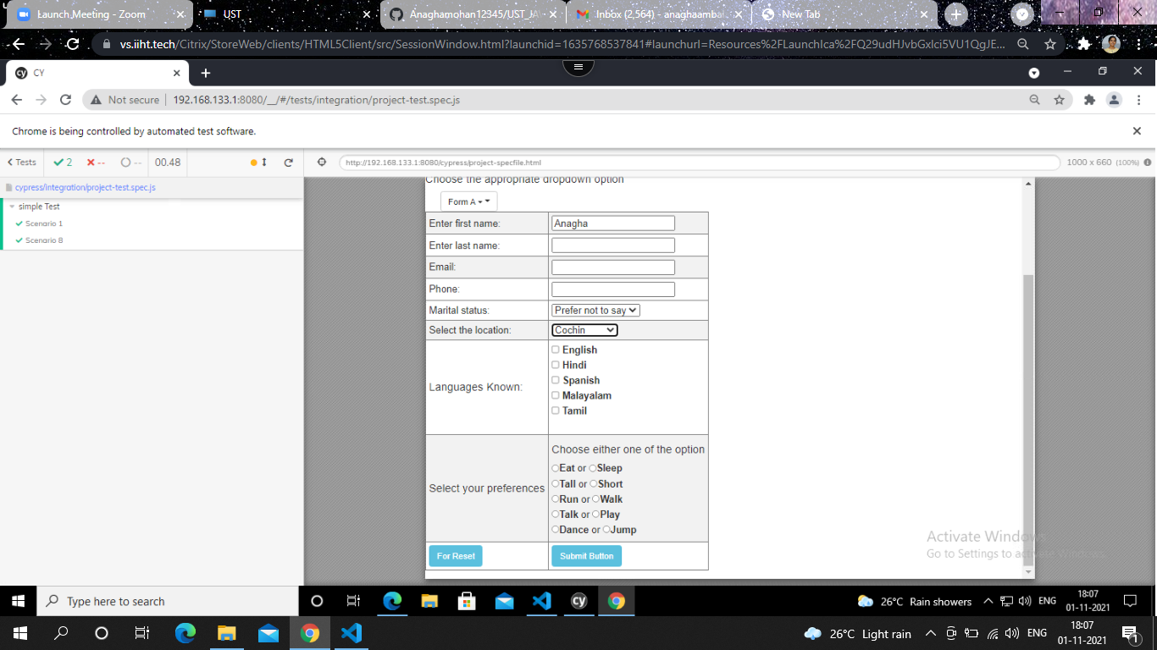

* TESTCASE 9

it('Scenario 9', function (){

         cy.get('#location').select('Trivandrum')

      });

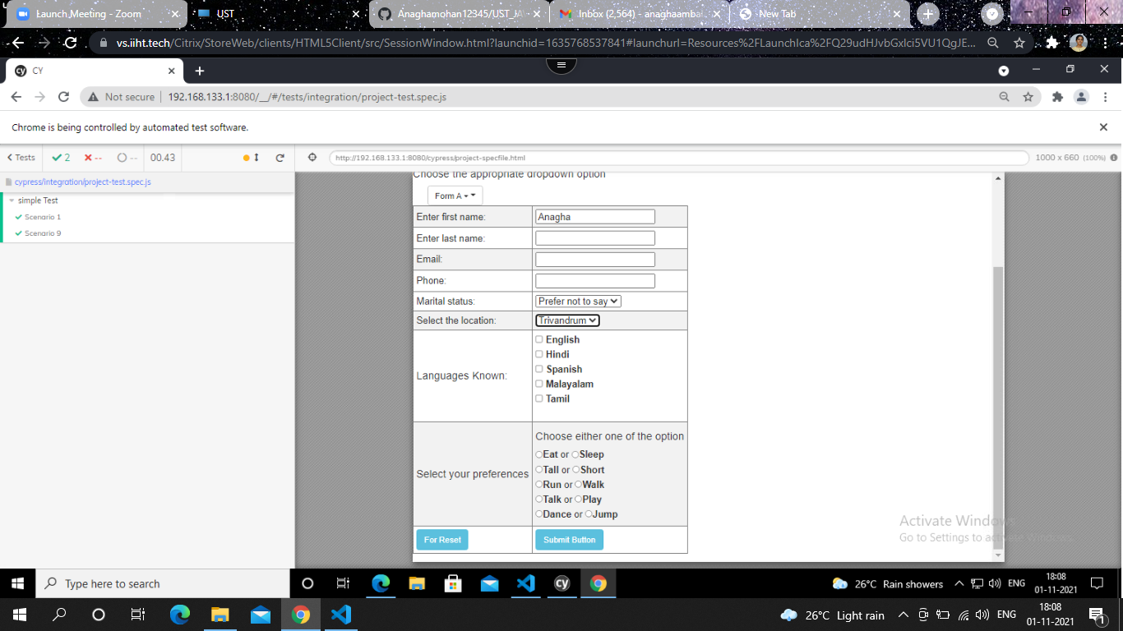

* TESTCASE 10

it('Scenario 10', function (){

         cy.visit("http://127.0.0.1:5500/cypress/project-specfile.html")

         cy.get('#mstatus').select('Unmarried')

         });

